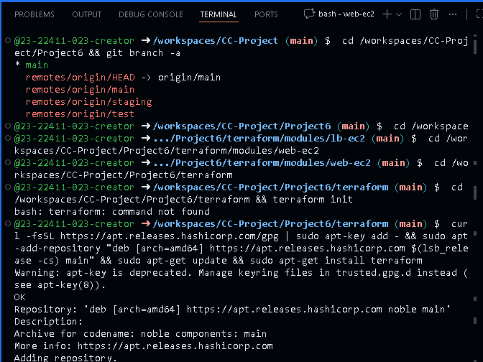
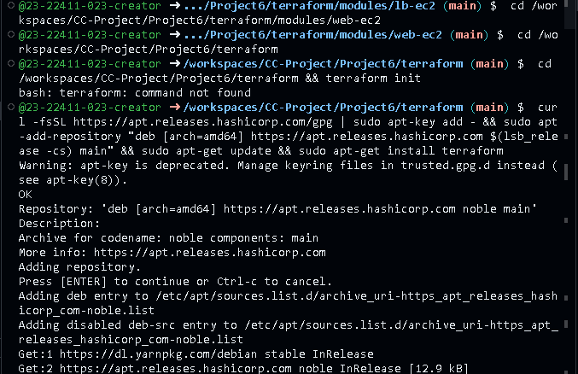
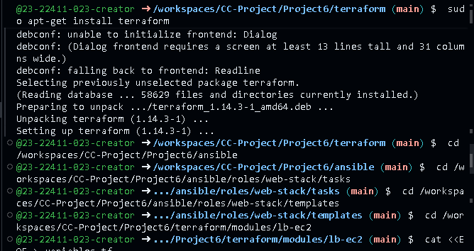
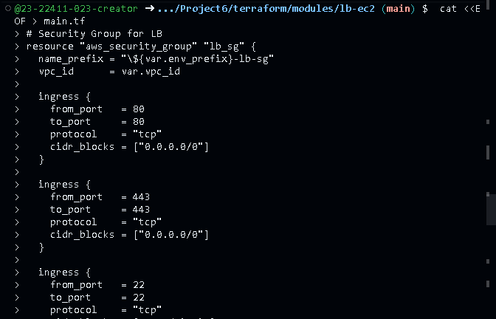
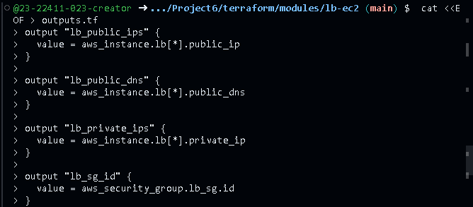
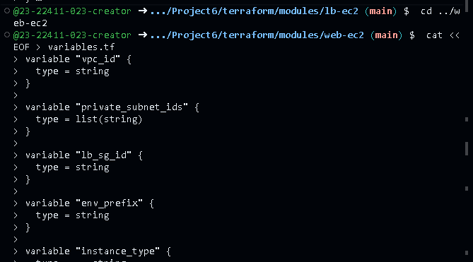
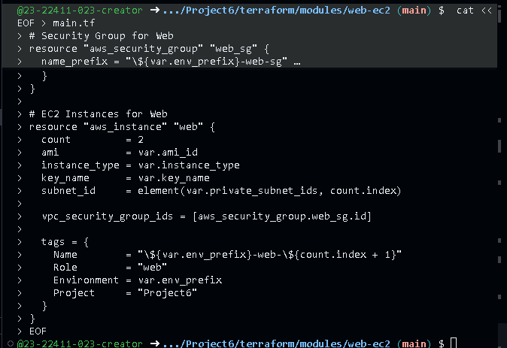
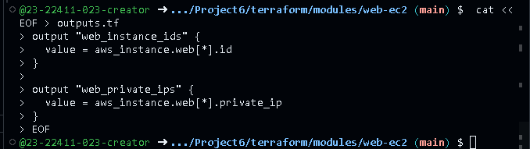
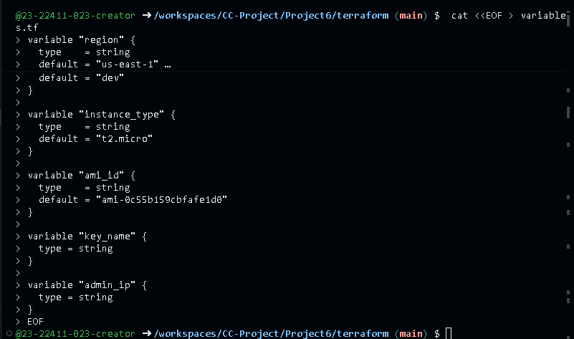
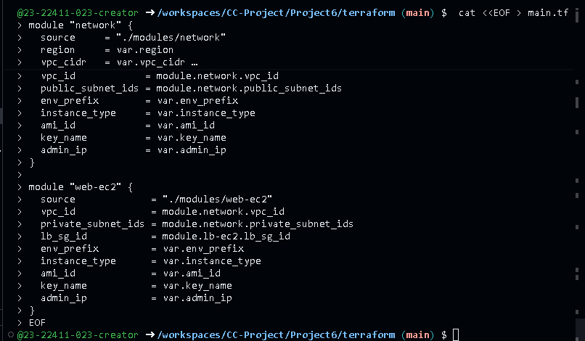
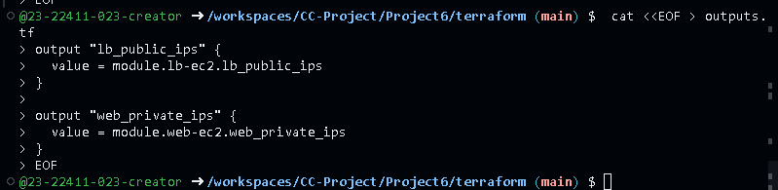
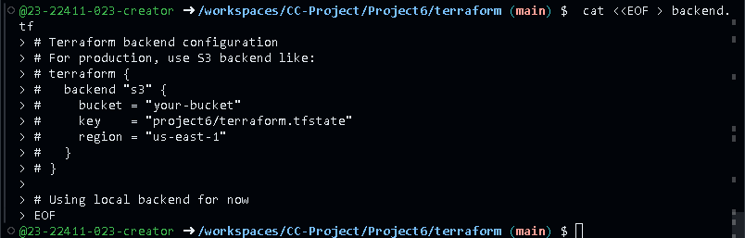
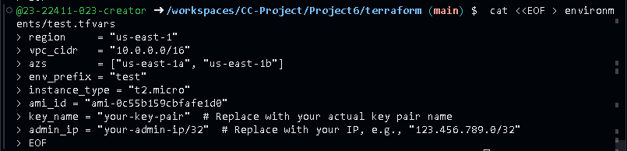
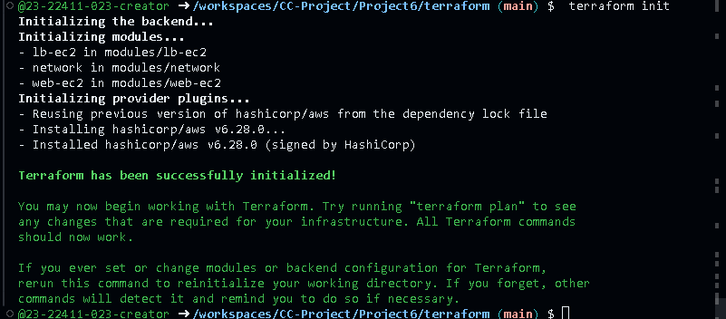
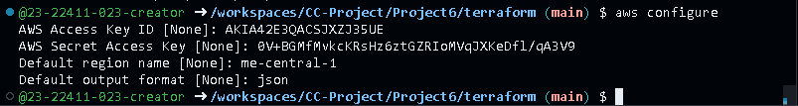
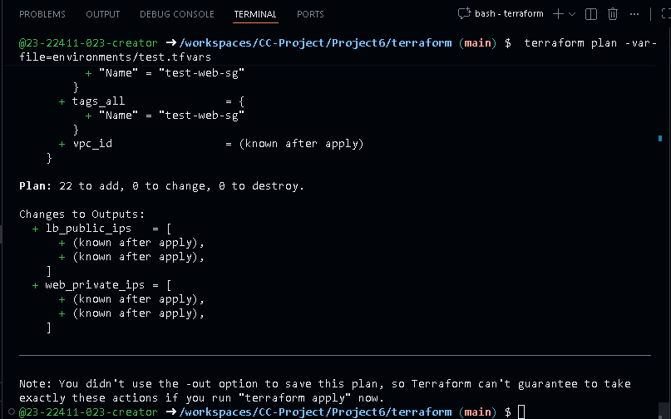
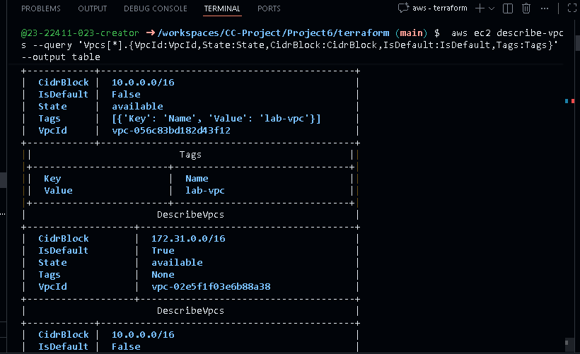
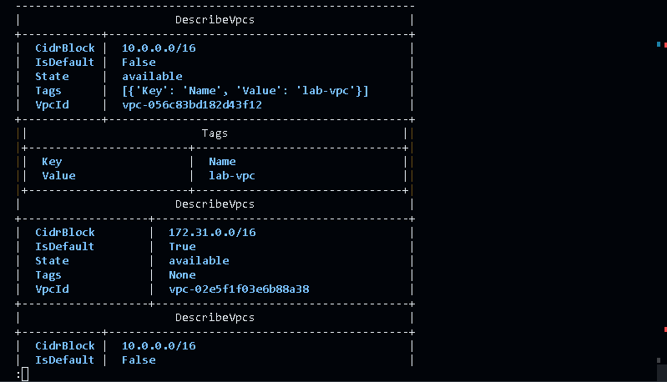
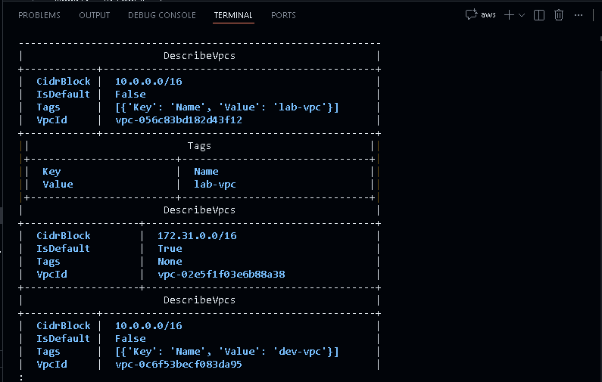
Overall Progress: Approximately 60-70% complete. Configuration code is written, but infrastructure is not provisioned, Ansible roles are not applied, and no testing or deployment has occurred.
What to Do Next
Follow these steps in order. Start in Project6.
- Checkout and merge branches locally:
  - Run: git checkout test
  - Run: git checkout staging
  - Run: git checkout main
- Deploy Terraform infrastructure (test environment first):

  - Run: cd terraform && terraform plan -var-file=environments/test.tfvars
  - If plan looks good, run: terraform apply -var-file=environments/test.tfvars
- Run Ansible playbooks to configure servers:
  - Run: cd ../ansible && ansible-playbook -i inventory/test_aws_ec2.yml playbooks/provision-web-stack.yml
  - Run: ansible-playbook -i inventory/test_aws_ec2.yml playbooks/deploy-websites.yml
  - Run: ansible-playbook -i

  - inventory/test_aws_ec2.yml playbooks/monitoring-checks.yml
- Test the setup:
  - Get LB public IP from Terraform outputs: cd ../terraform && terraform output
  - Run: curl -k https://<lb-public-ip> (replace with actual IP; test SSL and sites).
  - Check monitoring logs on servers via SSH.
- Commit changes and push:
  - Run: git add . && git commit -m "Deployed infrastructure and

  - configured Ansible"
  - Run: git push origin main
Repeat for staging/production environments by switching -var-file and inventory. If issues occur, debug with terraform destroy or Ansible retries.

